SKILL WALLET FSP
GLOBAL AI ADOPTION IN EDUCATION
Project Documentation

Student Name | Bhagyesh Rajshekhar Mhetre
College | Fabtech Technical Campus College of Engineering and Research, Sangola
Roll No. | 11
PRN | 23067561242013
Project Area | Data Analytics and Tableau Visualization
Project Title | Global AI Adoption in Education

Academic Year: 2026–27

Abstract
This project, developed under the Skill Wallet FSP framework, presents a Tableau-based data analytics study of Global AI Adoption in Education. The project analyzes a structured dataset containing 1,360 records and 16 attributes covering countries, regions, students, teachers, schools, daily AI usage, internet penetration, education index, government policy, urban/rural usage, curriculum inclusion, and gender gap. The objective is to transform raw data into interactive visual insights that explain how AI adoption varies geographically and across education stakeholders. Two dashboard views and a story-oriented presentation were used to communicate country-level adoption, rural-versus-urban usage, geographic trends, student-teacher comparison, school adoption by region, and adoption-level categories.
The supplied CSV contains data from 2015 to 2026. The analysis includes data-quality checking, missing-value assessment, aggregation, calculated categorization, visualization design, and dashboard interpretation. The final output is intended to support academic understanding of AI adoption patterns and demonstrate practical skills in data preparation, Tableau, visual analytics, and dashboard storytelling.

Table of Contents
1. Introduction
1.1 Project Overview
1.2 Objectives
2. Project Initialization and Planning Phase
2.1 Define Problem Statement
2.2 Project Proposal (Proposed Solution)
2.3 Initial Project Planning
3. Data Collection and Preprocessing Phase
3.1 Data Collection Plan and Raw Data Sources
3.2 Data Quality Report
3.3 Data Exploration and Preprocessing
4. Data Visualization
4.1 Framing Business Questions
4.2 Developing Visualizations
5. Dashboard
5.1 Dashboard Design File
6. Report
6.1 Story Design File
7. Performance Testing
7.1 Utilization of Data Filters
7.2 Number of Calculation Fields
7.3 Number of Visualizations
8. Conclusion / Observation
9. Future Scope
10. Appendix
10.1 Source Code (if any)

1. Introduction

1.1 Project Overview
Artificial Intelligence is increasingly being used in education for learning support, content generation, personalized learning, assessment, research assistance, and administrative tasks. However, adoption is not uniform across countries, regions, students, teachers, schools, and urban/rural communities. This project uses data visualization to study these differences and present them in an accessible dashboard format.
The project titled “Global AI Adoption in Education” uses Tableau as the primary visualization platform. The supplied dataset contains 1,360 rows and 16 columns. The dashboard design combines bar charts, a population/geographic map, a rural-versus-urban comparison, line charts, a student-versus-teacher comparison, an adoption-level breakdown, and a regional donut chart.
- Primary technology: Tableau
- Data format: CSV
- Records analyzed: 1,360
- Attributes analyzed: 16
- Source-data time coverage: 2015–2026
- Countries represented: 10
- Regions represented: 6

1.2 Objectives
- Analyze AI adoption among students, teachers, and schools.
- Compare AI usage between urban and rural communities.
- Identify geographic differences in educational AI adoption.
- Study changes in AI adoption over time.
- Compare country-level average daily AI usage.
- Visualize the role of curriculum inclusion, internet penetration, and government AI policy.
- Create interactive Tableau dashboards for academic and analytical reporting.
- Demonstrate practical skills in data cleaning, aggregation, calculated fields, visualization, and dashboard storytelling.

2. Project Initialization and Planning Phase

2.1 Define Problem Statement
Educational institutions and decision-makers need a clear way to understand how AI is being adopted by students, teachers, and schools across different geographic areas. Raw datasets are difficult to interpret directly. The problem addressed by this project is therefore to convert multidimensional AI-in-education data into meaningful visual information that can reveal adoption patterns, geographic differences, stakeholder usage, and rural-urban gaps.

2.2 Project Proposal (Proposed Solution)
The proposed solution is an interactive Tableau analytics dashboard and story. The CSV dataset is imported into Tableau, checked for data quality, explored using dimensions and measures, and then transformed into multiple visualizations. Dashboards combine these visualizations into a single analytical interface so that users can compare countries, regions, years, and education stakeholders.
- Input: Global AI in Education CSV dataset.
- Processing: data validation, missing-value review, aggregation, calculated fields.
- Visualization: Tableau charts, map, comparison views, and dashboard/story.
- Output: analytical dashboards and project documentation.

2.3 Initial Project Planning
Phase | Activity | Status
Phase 1 | Understand project requirement and dashboard objective | Completed
Phase 2 | Import and inspect CSV dataset | Completed
Phase 3 | Check data types, missing values, and categories | Completed
Phase 4 | Build individual Tableau visualizations | Completed
Phase 5 | Assemble dashboards and story | Completed
Phase 6 | Review visual consistency and interpretation | Completed
Phase 7 | Prepare documentation | Current deliverable

3. Data Collection and Preprocessing Phase

3.1 Data Collection Plan and Raw Data Sources
The raw data source supplied for this project is the CSV file “Global AI in Education (1).csv”. It contains 1,360 records with 16 fields. The fields represent time, geography, AI usage, school adoption, technology usage, education context, policy, curriculum, and demographic gap measures.
Field | Meaning | Data Type
year | Year of observation | Integer
month | Month of observation | Integer
country | Country | Categorical
region | Geographic region | Categorical
student_ai_usage_pct | Student AI usage percentage | Numeric
teacher_ai_usage_pct | Teacher AI usage percentage | Numeric
schools_ai_adoption_pct | School AI adoption percentage | Numeric
avg_daily_ai_usage_min | Average daily AI usage in minutes | Numeric
top_ai_tool | Most represented AI tool | Categorical
internet_penetration_pct | Internet penetration percentage | Numeric
education_index | Education index | Numeric
government_ai_policy | Government AI policy status | Categorical
urban_ai_usage_pct | Urban AI usage percentage | Numeric
rural_ai_usage_pct | Rural AI usage percentage | Numeric
ai_in_curriculum | Whether AI is included in curriculum | Categorical
gender_gap_ai_usage_pct | Gender gap in AI usage | Numeric

3.2 Data Quality Report
The dataset contains 1,360 rows and 16 columns. A total of 441 missing cells were detected. All missing cells occur in the government_ai_policy field: 441 rows (32.43%). The remaining 15 fields contain no missing values in the supplied CSV.
Quality Check | Result
Total rows | 1,360
Total columns | 16
Duplicate check | No duplicate rows detected in the supplied records
Total missing cells | 441
Missing in government_ai_policy | 441 (32.43%)
Missing in other fields | 0
Year range | 2015–2026
Countries | 10
Regions | 6

Because government_ai_policy has substantial missingness, policy-based interpretations should distinguish records with an available policy status from records where the value is missing. For dashboard presentation, missing policy values should not automatically be treated as either Active or Draft unless a documented project rule is applied.

3.3 Data Exploration and Preprocessing
The preprocessing workflow consisted of inspecting the schema, confirming numerical and categorical fields, checking ranges, identifying missing values, and preparing dimensions and measures for Tableau. No missing-value problem exists for the core usage metrics used in the main dashboard views.
Measure | Observed Range
Student AI usage (%) | 0–65
Teacher AI usage (%) | 0–60
School AI adoption (%) | 0–62
Daily AI usage (minutes) | 5–60
Urban AI usage (%) | 0–70
Rural AI usage (%) | 0–59
Internet penetration (%) | 42–96
Education index | 0.52–0.94

The dashboard uses aggregated measures such as average AI usage, average student/teacher usage, and regional/country comparisons. The project also includes an adoption-level breakdown with High Adoption, Moderate Adoption, and Low Adoption categories. The exact threshold definition should be retained in the Tableau workbook because the supplied screenshot does not expose the threshold values.

4. Data Visualization

4.1 Framing Business Questions
- Which countries show higher or lower average daily AI usage in education?
- How does AI usage differ between urban and rural communities?
- How has student, teacher, and school AI adoption changed over time?
- How do student and teacher AI usage compare across countries?
- How does school AI adoption vary by region?
- What is the distribution of High, Moderate, and Low AI adoption records?
- Is AI represented in the education curriculum across the dataset?
- What AI tools are represented most frequently?

4.2 Developing Visualizations
Visualization | Main Fields | Purpose
Country-level bar chart | Country vs. average daily AI usage | Compare countries
Rural/Urban mirrored bar chart | Year vs. rural and urban usage | Compare community types over time
Geographic map | Country/region | Show spatial distribution
Adoption journey line chart | Year vs. student/teacher/school measures | Show temporal trend
Student vs. teacher grouped bars | Country vs. two usage measures | Stakeholder comparison
Adoption-level bar chart | Adoption category vs. record count | Category distribution
Regional donut chart | Region vs. school adoption measure | Regional comparison

Figure 1: Primary Global AI Adoption Dashboard
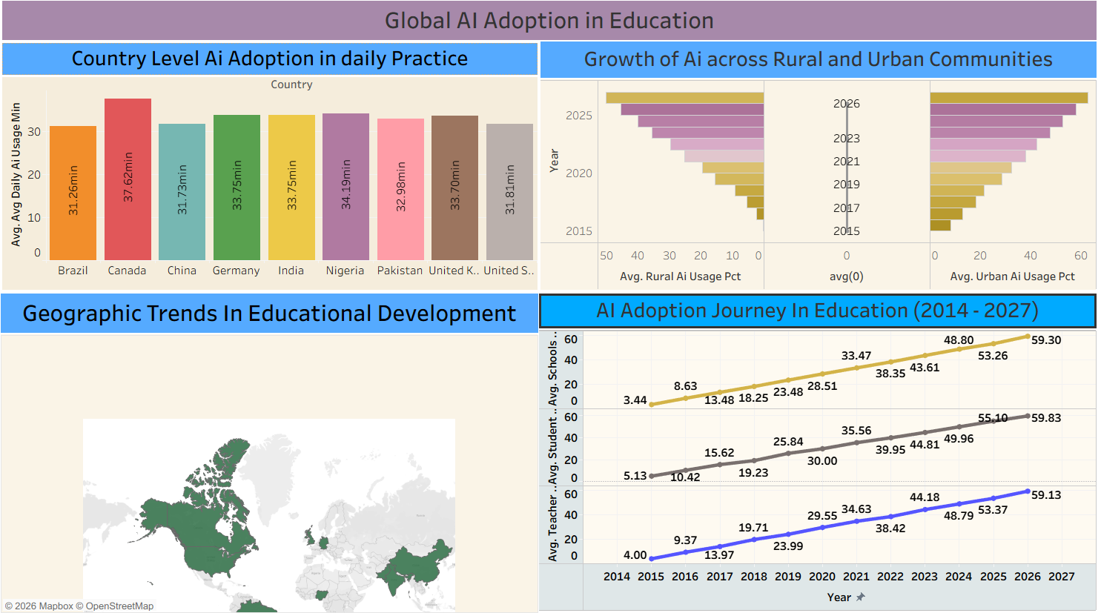
Figure 1. Tableau dashboard showing country adoption, rural/urban growth, geographic trends, and adoption journey.
The first dashboard combines four analytical areas. The upper-left view compares average daily AI usage by country. The upper-right view compares rural and urban AI usage over time. The lower-left view provides a geographic map, while the lower-right view presents an adoption journey over time for schools, students, and teachers. The dashboard is designed to provide both geographic and time-series perspectives.

Figure 2: Comparative AI Adoption Dashboard
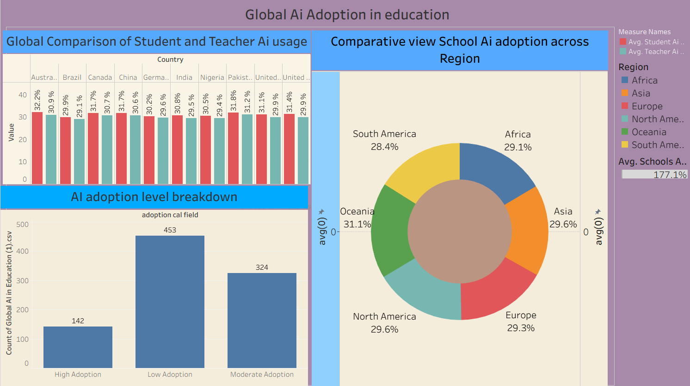
Figure 2. Comparative dashboard showing student-teacher usage, adoption levels, and regional school adoption.
The second dashboard focuses on comparison. The grouped bar chart compares student and teacher AI usage across countries. The adoption-level chart groups records into High, Moderate, and Low Adoption. The donut chart provides a regional comparison of school AI adoption. These views make the dashboard useful for stakeholder-oriented analysis.

5. Dashboard

5.1 Dashboard Design File
The dashboard design follows a multi-panel layout. Headings are used to identify each analytical question, while consistent typography and contrasting section headers separate visual groups. The first dashboard emphasizes global adoption and trends; the second emphasizes comparative stakeholder and regional analysis.
Component | Structure | Description
Dashboard 1 | 4 main visual areas | Global adoption, rural/urban, map, time trend
Dashboard 2 | 3 main visual areas | Student-teacher, adoption levels, regional comparison
Visual style | Panel-based | Clear section titles and direct labels
Interactivity | Dimension/measure driven | Country, region, year and categorical analysis
Storytelling | Sequential comparison | From global overview to stakeholder/region detail

The first screenshot includes a trend panel labeled “AI Adoption Journey in Education (2014–2027)”. However, the supplied CSV itself contains observations from 2015 through 2026. Therefore, the documentation records the CSV coverage as 2015–2026 and treats the 2014–2027 label as part of the dashboard presentation. If this project is submitted for formal evaluation, the Tableau axis should be checked against the final workbook so that the displayed range and source-data range agree.

6. Report

6.1 Story Design File
The project story can be presented in the following sequence: (1) introduce the global AI adoption problem, (2) show country-level daily usage, (3) compare rural and urban communities, (4) inspect geographic distribution, (5) examine the adoption journey over time, (6) compare student and teacher usage, and (7) conclude with regional and adoption-level observations. This sequence moves from overview to comparison and then to detailed interpretation.
Story Point | View | Narrative Purpose
Story Point 1 | Global overview | Introduce the dataset and project objective
Story Point 2 | Country comparison | Compare average daily AI usage
Story Point 3 | Rural vs Urban | Highlight community-level differences
Story Point 4 | Geographic trends | Use map to show country distribution
Story Point 5 | Adoption journey | Observe change over time
Story Point 6 | Student vs Teacher | Compare stakeholder usage
Story Point 7 | Regional adoption | Summarize regional school adoption

7. Performance Testing

7.1 Utilization of Data Filters
Filtering and aggregation are important for making the dashboard interactive and reducing the amount of information shown at one time. The project uses country, region, year, and categorical dimensions in its analytical views. The supplied screenshots do not show a separate filter-card panel clearly enough to establish an exact filter count; therefore, this report documents the analytical dimensions rather than inventing a filter count.
Dimension | Use | Analytical Importance
Country | Used for country-level comparison | High
Region | Used for regional comparison | High
Year | Used for trend analysis | High
Adoption category | Used for High/Moderate/Low breakdown | Medium
AI in curriculum | Categorical analytical dimension | Medium
Government policy | Policy-status analysis; contains missing values | Medium

7.2 Number of Calculation Fields
At least one project-specific calculated field is visibly represented in the supplied dashboard: the adoption-level classification used to group records into High Adoption, Moderate Adoption, and Low Adoption. Tableau also performs standard aggregations such as AVG and COUNT automatically. Because the underlying .twb/.twbx workbook was not supplied, an exact total number of calculated fields cannot be verified from the screenshots alone.
- Visible project-specific calculated classification: Adoption Level.
- Standard Tableau aggregations: AVG and COUNT are used in the displayed views.
- Exact workbook-level calculated-field count: not verifiable without the Tableau workbook.

7.3 Number of Visualizations
Seven major visualizations are visible across the two supplied dashboards: four in the first dashboard and three in the second. These include bar charts, a mirrored bar chart, a map, a line chart, a grouped comparison chart, an adoption-level chart, and a donut chart.
Dashboard | Count | Views
Dashboard 1 | 4 | Country bar, rural/urban comparison, map, adoption journey
Dashboard 2 | 3 | Student-teacher comparison, adoption-level breakdown, regional donut
Total visible major views | 7 | Across the two supplied dashboard screenshots

8. Conclusion / Observation
The supplied dataset contains 1,360 records from 2015 to 2026, representing 10 countries and 6 regions. Across the complete dataset, the average student AI usage is 30.99%, average teacher AI usage is 29.91%, and average school AI adoption is 29.41%. Average daily AI usage is 32.82 minutes.
A notable descriptive pattern is the difference between average urban AI usage (33.56%) and rural AI usage (21.60%) in the supplied records. The dashboards make this difference easier to inspect over time and by geography. The project also shows that AI adoption can be studied from several perspectives rather than through a single indicator.
The data-quality review identified 441 missing government policy values, while the other fields were complete. This is important when interpreting policy-related charts. Overall, the project demonstrates how a multidimensional education dataset can be converted into a structured Tableau story that supports descriptive analysis.

Key Year-wise Observations
Year | Student | Teacher | Schools | Urban | Rural
2015 | 4.98% | 4.04% | 3.38% | 7.83% | 0.16%
2018 | 19.32% | 19.46% | 18.36% | 21.74% | 9.06%
2020 | 30.03% | 29.32% | 28.45% | 32.38% | 20.10%
2022 | 39.95% | 38.58% | 38.48% | 42.50% | 29.61%
2024 | 49.90% | 49.08% | 48.68% | 52.48% | 40.00%
2026 | 60.75% | 59.00% | 59.25% | 63.55% | 50.58%

9. Future Scope
- Add more countries and a longer historical period.
- Connect the dashboard to a live or regularly refreshed data source.
- Add institution-level or state/province-level education data.
- Include socioeconomic indicators and device availability.
- Analyze AI tool categories such as generative AI, tutoring systems, coding assistants, and assessment tools.
- Add predictive analytics to estimate future adoption patterns.
- Develop drill-down dashboards for individual countries and regions.
- Improve policy analysis after completing or validating missing government-policy records.
- Add user-controlled filters and parameters if the final Tableau workbook supports them.
- Publish the final dashboard with an accompanying methodology and data dictionary.

10. Appendix

10.1 Source Code (if any)
This project is primarily a Tableau visualization project, so the main implementation is stored in the Tableau workbook rather than in a conventional application source-code file. The CSV is the analytical input. Any Tableau calculated fields, worksheets, dashboards, filters, parameters, and story points should be preserved in the final .twb or .twbx project file.
Recommended project files for submission:
- Global AI in Education (1).csv – raw analytical dataset.
- Final Tableau workbook (.twb or .twbx) – worksheets, dashboards, calculations, and story.
- Project documentation (.docx) – this report.
- Dashboard screenshots – supporting evidence of the final visualization.

Appendix A: Dataset Summary
Metric | Value
Rows | 1,360
Columns | 16
Countries | 10
Regions | 6
Years | 2015–2026
Missing cells | 441
Missing policy values | 441
Average student usage | 30.99%
Average teacher usage | 29.91%
Average school adoption | 29.41%
Average daily usage | 32.82 minutes
Average urban usage | 33.56%
Average rural usage | 21.60%

Appendix B: Country Summary
Country | Daily Min | Student | Teacher | Schools | Urban | Rural
Canada | 35.46 | 31.07% | 29.94% | 29.53% | 33.54% | 21.32%
Australia | 34.43 | 31.01% | 29.78% | 29.63% | 33.60% | 21.72%
Nigeria | 33.66 | 30.88% | 29.58% | 29.50% | 33.57% | 21.49%
Pakistan | 33.18 | 31.03% | 30.24% | 29.65% | 33.75% | 21.51%
China | 33.09 | 30.90% | 29.78% | 28.96% | 33.51% | 21.35%
India | 32.99 | 31.00% | 29.92% | 29.15% | 33.48% | 21.91%
United Kingdom | 32.82 | 31.01% | 29.84% | 29.21% | 33.43% | 21.74%
Germany | 32.08 | 30.76% | 30.23% | 29.84% | 33.46% | 21.34%
Brazil | 30.34 | 30.60% | 29.81% | 29.41% | 33.18% | 21.32%
United States | 30.18 | 31.61% | 29.96% | 29.21% | 34.10% | 22.31%

Appendix C: Frequently Represented AI Tools
AI Tool | Records | Share of Dataset
ChatGPT | 363 | 26.69%
Microsoft Copilot | 341 | 25.07%
Google Gemini | 330 | 24.26%
Khanmigo | 326 | 23.97%

Appendix D: Important Submission Note
The statistics in this document are calculated directly from the supplied CSV file. The visual descriptions are based on the two supplied Tableau dashboard screenshots. Where a Tableau workbook feature cannot be verified from a screenshot—such as the exact number of calculated fields, exact filter cards, or the threshold values behind the adoption-level classification—the report explicitly marks it as not verifiable rather than inventing a value.

